

**FPT APTECH COMPUTER EDUCATION**

Do Hoang Giang A04991

Vu Viet Hung A04990

Tong Manh Long A04977

**School Management System**

**Documentation**

SCHOOL MANAGEMENT SYSTEM

DOCUMENTATION

© FPT Aptech Center 1

Vietnam – Soviet Culture Hall

Hanoi, Vietnam

Phone 0989044086

Contents

Problem Definition 1

Customer Requirement Specification (CRS) 1

Architecture & Design of the Project 4

Entity Relationship (ER) diagram 6

Database Design/ Structure 9

Flowchart 14

GUI 24

**Section**

1

Problem Definition

In this form, we define the problem statement.

Introduction

S

chool Management System is software which is helpful for teacher (staff) and students. In the current system all the activities are done manually. Our School Management System (SMS) deals with the various activities related to the teachers and students. There are mainly 3 modules in this software : Administrator , Staff (Teacher), Student. In this software, we cant register for themselves. Administrator will create account for staffs. Staff will create account for students. Administrator has the power to add new staff, edit staff, delete staff, search staff. Staffs can add new student, edit student, delete student, search student and mark management for student. Student can enter registraton number to view mark, batch and personal information.

System analysis

S

ystem Analysis is a detailed study of the various operations performed by system and relationship inside or outside of the system. “What are all problems exists in the system?” is the key question. What mus be done to solve the problem? During analysis, data collected on the various file, decision point handled by the present system. The commonly ysed tools in the system are SQL Diagram, system prototype, ERD, etc. Training, experience and common sense are needed to develop the SMS. The success of SMS depends largely on how clearly the problem is defined, understand thoroughly and properly carried out through the chose of solution. A good analysis model should provide both the frame work of the solution and the mechanisms of problem understanding. System analysis can be categorized into three parts: System planning and find out, Collect information, Structural analysis.

Propose system

I

n our proposed system we have the provision for adding the details of staff bay administrator and details of student by staff (teacher). So the management become easier and more convenient. Another advantage of the system is that it is very easy to edit details of the staff as well as student and delete a staff or a student when it found unnecessary. All information are added in the database and so all user can also view their information whenever they want. Our proposed system has some advantage: Friendly and stunning interface, Fast access to database, Less error, Look and Feel Environment, Quick actions.

**Section**

2

Customer Requirement Specification (CRS)

In this form, we address organization/business overview, products, concerns and expectation from the system.

Users of the system

i

n order to meet the requirements of the system, there must at least be **3** types of users. They are :

1. **Admins** : are the person who is responsible for setting up and maintaining the system. Additionally, admins can view the statistic charts of interviews, interviewers, schedulers, companies in a specific a range of time.
2. **Schedulers** : are the person who is responsible for scheduling interviews and manipulating data of the Marvell Consultancies Ltd. Additionally, schedulers can view the fee of charge that a specific company must pay to Marvell Consultancies Ltd. Moreover, schedulers can interact with interviewers to change some arranged interview to a new date.
3. **Interviewers** : are the person who is responsible for taking interviews, approving or disaproving a job seeker, negotiating the acceptable salary with seekers . Additionally, interviewers can interact with schedulers to propose changes in date of arranged interviews some
4. **Admin operations:**

- Login.

- Log out.

- Scheduler and Interviewer Management.

- View statistic information on schedulers, interviewers, interviews, companies.

- Change my password

1. **Scheduler operations:**

- Login.

- Log out.

- Job Seeker Management.

- Vacancy Management.

- Company Management

- Skills and Fields Management

- Interviewer Request Handling

- Accounting Management

- Interview Scheduling

- Message management

- View filtered data of seekers and vacancies

1. **Interviewers operations:**

- Login.

- Log out.

- View information of assigned coming interview

- Set mark for each interview after interviewing

- Set the salary after negotiation

- Request to change date of interview if neccessary

- Change my password

T

System functions

ere are **10** main functions:

1. Authentication
2. User Management
3. Job Seeker Management
4. Vacancy Management
5. Company Management
6. Skill and Field Management
7. Interviewers ’ Request Handling
8. Accounting Management
9. Interview Scheduling
10. Interview Assessment

**Section**

3

Architecture & Design of the Project

In this form, we provide the architecture and design of our project

Architecture

t

he application has a three-tier architecture

**Section**

4

Entity Relationship (ER) diagram

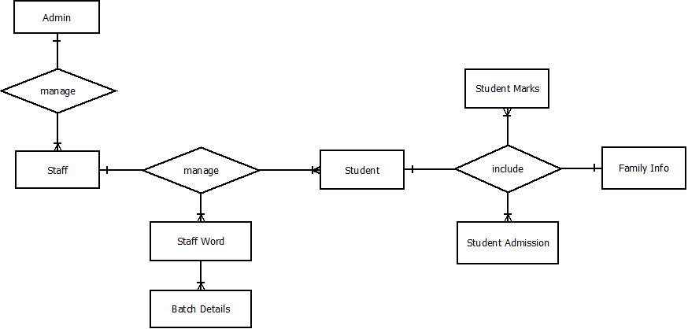

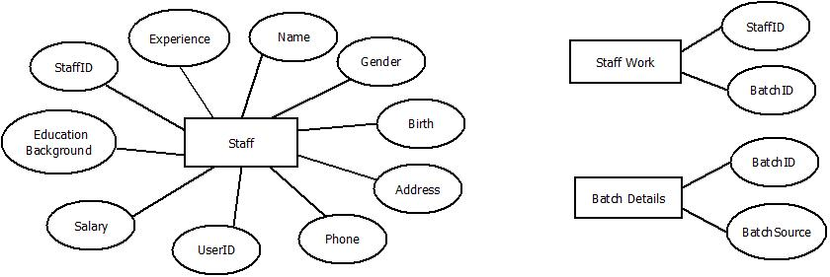

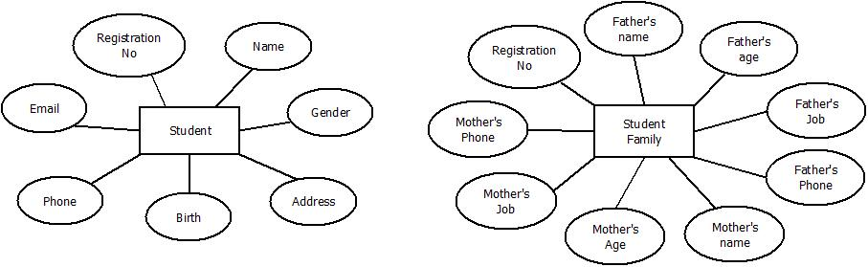

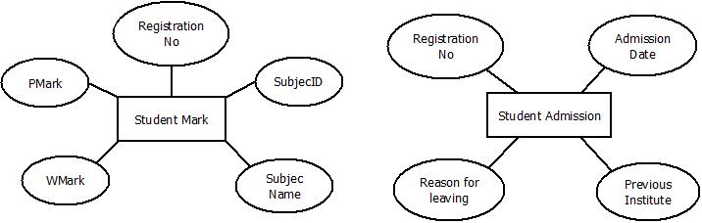

**Section**

5

Database Design/ Structure

Table is a set of data elements (cells) that is organized, defined and stored

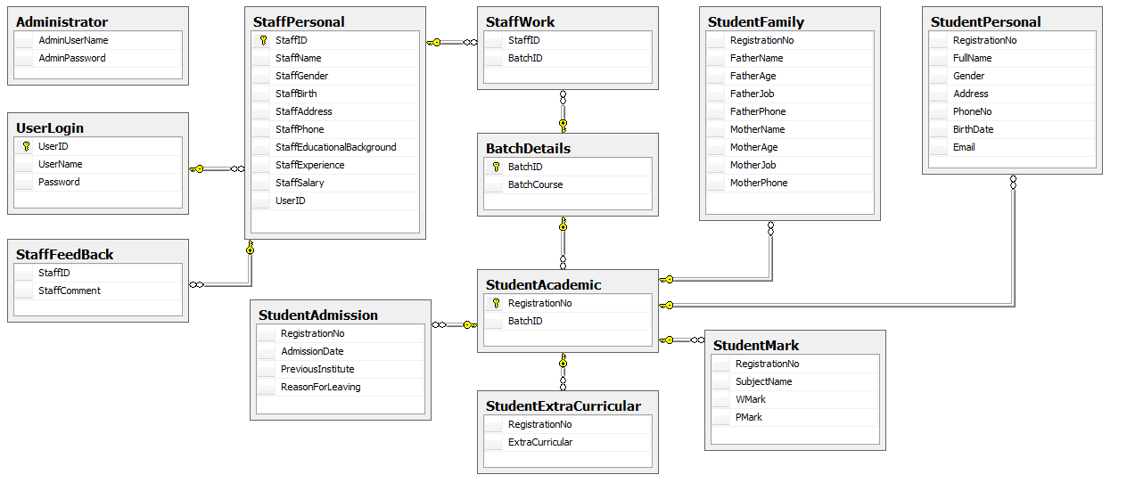

|  |  |  |  |  |
| --- | --- | --- | --- | --- |
| Table : Administrator | | | | |
| Field name | **Data type** | **Null** | **Key** | **Description** |
| AdminUserName | nvarchar(30) | No | PK | Store Username of Administrator |
| AdminPassword | nvarchar(12) | No |  | Store Password of Administrator |

|  |  |  |  |  |
| --- | --- | --- | --- | --- |
| Table : BatchDetails | | | | |
| Field name | **Data type** | **Null** | **Key** | **Description** |
| BatchID | nvarchar(6) | No | PK | Store ID of batch |
| BatchSource | nvarchar(4) | No |  | Store batch source |

|  |  |  |  |  |
| --- | --- | --- | --- | --- |
| Table : StaffFeedback | | | | |
| Field name | **Data type** | **Null** | **Key** | **Description** |
| StaffID | nvarchar(6) | No | PK | Store ID of batch |
| StaffComment | nvarchar(100) | Yes |  | Store batch source |

|  |  |  |  |  |
| --- | --- | --- | --- | --- |
| Table : StaffPersonal | | | | |
| Field name | **Data type** | **Null** | **Key** | **Description** |
| StaffID | nvarchar(6) | No | PK | Store ID of staff |
| StaffName | nvarchar(30) | No |  | Store Staff’s name |
| StaffGender | nvarchar(6) | No |  | Store Staff’s gender |
| StaffBirth | datetime | No |  | Store Staff’s birthday |
| StaffAddress | nvarchar(100) | Yes |  | Store Staff’s address |
| StaffPhone | int | Yes |  | Store Staff’s phone number |
| StaffEducationBackground | nvarchar(20) | No |  | Store Staff’s education background |
| StaffExperience | int | Yes |  | Store Staff’s experience |
| StaffSalary | float | Yes |  | Store Staff’s salary |
| UserID | nvarchar(6) | yes |  | Store Staff’s user ID |

|  |  |  |  |  |
| --- | --- | --- | --- | --- |
| Table : StaffWork | | | | |
| Field name | **Data type** | **Null** | **Key** | **Description** |
| StaffID | nvarchar(6) | No | PK | Store StaffID |
| BatchID | nvarchar(6) | No |  | Store BatchID |

|  |  |  |  |  |
| --- | --- | --- | --- | --- |
| Table : StudentAcademic | | | | |
| Field name | **Data type** | **Null** | **Key** | **Description** |
| RegistrationNo | nvarchar(6) | No | PK | Store student’s registration number |
| BatchID | nvarchar(6) | Yes |  | Store BatchID |

|  |  |  |  |  |  |
| --- | --- | --- | --- | --- | --- |
| Table : StudentAdmission | | | | | |
| Field name | **Data type** | | **Null** | **Key** | **Description** |
| RegistrationNo | nvarchar(6) | | No | FK | Store student’s registration number |
| AdmissionDate | datetime | | Yes |  | Store admission date |
| PreviousInstitute | | nvarchar(20) | Yes |  | Store previous institute of student |
| ReasonForLeaving | | nvarchar(20) | Yes |  | Store reason for leaving |

|  |  |  |  |  |
| --- | --- | --- | --- | --- |
| Table : StudentExtraCurricular | | | | |
| Field name | **Data type** | **Null** | **Key** | **Description** |
| RegistrationNo | nvarchar(6) | No | FK | Store student’s registration number |
| ExtraCurricular | nvarchar(6) | Yes |  | Store Extra Curricular |

|  |  |  |  |  |
| --- | --- | --- | --- | --- |
| Table : UserLogin | | | | |
| Field name | **Data type** | **Null** | **Key** | **Description** |
| UserID | nvarchar(6) | No | PK | Store user ID of staff |
| UserName | nvarchar(30) | Yes |  | Store user name of staff to login |
| UserPassword | nvarchar(12) | Yes |  | Store user password of staff to login |

|  |  |  |  |  |
| --- | --- | --- | --- | --- |
| Table : StudentFamily | | | | |
| Field name | **Data type** | **Null** | **Key** | **Description** |
| RegistrationNo | nvarchar(6) | No | FK | Store student’s registration number |
| FatherName | nvarchar(30) | Yes |  | Store student’s father name |
| FatherAge | int | Yes |  | Store age of father |
| FatherJob | nvarchar(20) | Yes |  | Store job of father |
| FatherPhone | int | Yes |  | Store father’s phone number |
| MotherName | nvarchar(30) | Yes |  | Store student’s mother name |
| MotherAge | int | Yes |  | Store age of mother |
| MotherJob | nvarchar(20) | Yes |  | Store job of mother |
| MotherPhone | int | Yes |  | Store mother’s phone number |

|  |  |  |  |  |
| --- | --- | --- | --- | --- |
| Table : StudentMark | | | | |
| Field name | **Data type** | **Null** | **Key** | **Description** |
| RegistrationNo | nvarchar(6) | No | FK | Store student’s registration number |
| SubjectName | nvarchar(20) | No |  | Store subject name |
| WMark | int | Yes |  | Store mark of theory |
| PMark | int | Yes |  | Store mark of practice |

|  |  |  |  |  |
| --- | --- | --- | --- | --- |
| Table : StudentPersonal | | | | |
| Field name | **Data type** | **Null** | **Key** | **Description** |
| RegistrationNo | nvarchar(6) | No | FK | Store student’s registration number |
| Fullname | nvarchar(30) | Yes |  | Store full name of student |
| Gender | nvarchar(6) | Yes |  | Store gender of student |
| Address | nvarchar(100) | Yes |  | Store address of student |
| PhoneNo | int | Yes |  | Store phone number of student |
| BirthDate | datetime | Yes |  | Store student’s birthday |
| Email | nvarchar(100) | Yes |  | Store email of student |

**Section**

6

Flowchart

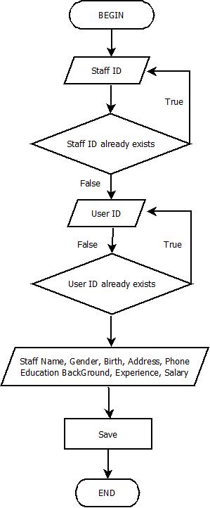

1. Add staff

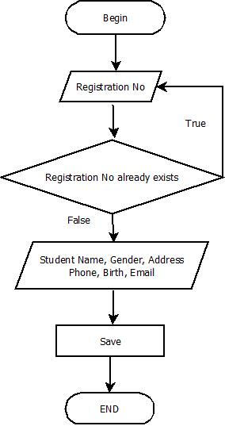

1. Add student

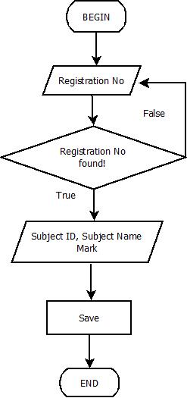

1. Add subject

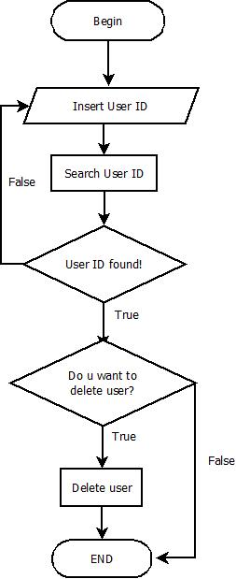

1. Delete user

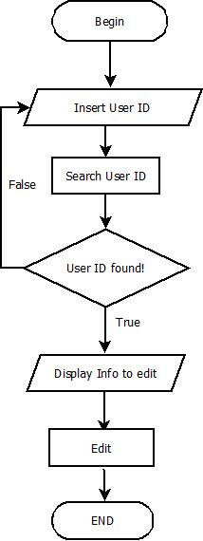

1. Edit staff

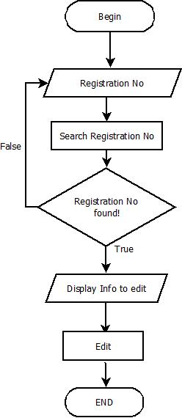

1. Edit student

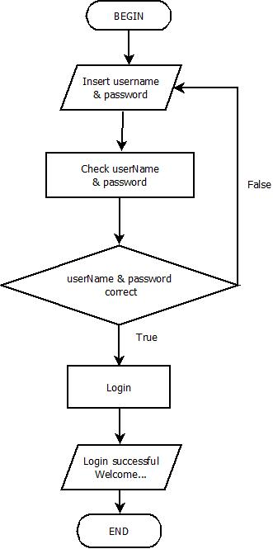

1. Login

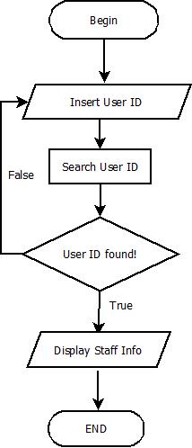

1. Search Staff

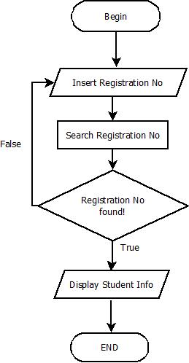

1. Search Student

**Section**

8

GUI

1. **Connection form**
   1. **Connect Form**

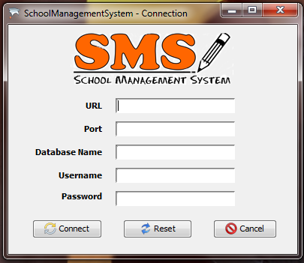

|  |  |  |  |  |  |
| --- | --- | --- | --- | --- | --- |
| No | Name | Type | Validation | Event | Description |
| 1 | btnConnect | Button |  | Yes | Connect to database |
| 2 | btnReset | Button |  | Yes | Clear all textfield |
| 3 | btnCancel | Button |  | Yes | Exit application |
| 4 | url | TextField | Not blank | No | Url of sqlserver |
| 5 | port | TextField | Not blank | No | Port to connect |
| 6 | dbName | TextField | Not blank | No | Database Name |
| 7 | userName | TextField | Not blank | No | Username to connect |
| 8 | pass | TextField | Not blank | No | Password to connect |

* 1. **Welcome**

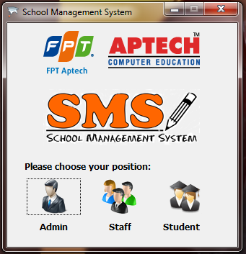

|  |  |  |  |  |  |
| --- | --- | --- | --- | --- | --- |
| No | Name | Type | Validation | Event | Description |
| 1 | adminBtn | Button |  | Yes | Go to admin login form |
| 2 | staffBtn | Button |  | Yes | Go to staff login form |
| 3 | stuBtn | Button |  | Yes | Go to student form |

1. **Login form**
   1. **Admin login**

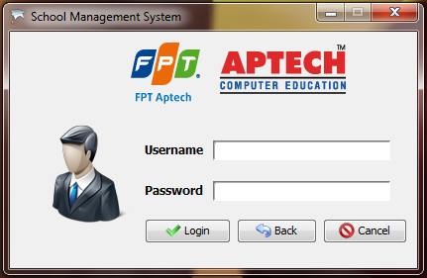

|  |  |  |  |  |  |
| --- | --- | --- | --- | --- | --- |
| No | Name | Type | Validation | Event | Description |
| 1 | userName | TextField | Not blank | No | Name to login |
| 2 | password | PasswordField | Not blank | No | Password to login |
| 3 | btnExit | Button |  | Yes | Exit |
| 4 | btnBack | Button |  | Yes | Back to Welcome form |
| 5 | btnLogin | Button |  | Yes | Login application |

* 1. Staff Login

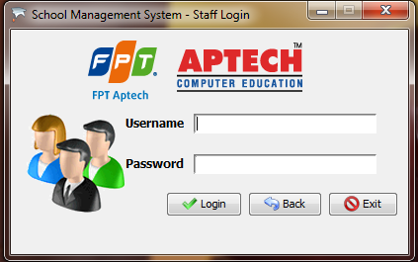

|  |  |  |  |  |  |
| --- | --- | --- | --- | --- | --- |
| No | Name | Type | Validation | Event | Description |
| 1 | userName | TextField | Not blank | No | Name to login |
| 2 | password | PasswordField | Not blank | No | Password to login |
| 3 | btnExit | Button |  | Yes | Exit |
| 4 | btnBack | Button |  | Yes | Back to Welcome form |
| 5 | btnLogin | Button |  | Yes | Login application |

* 1. **Student Info**

After click Student Icon at Welcome form, Student Info will appear:

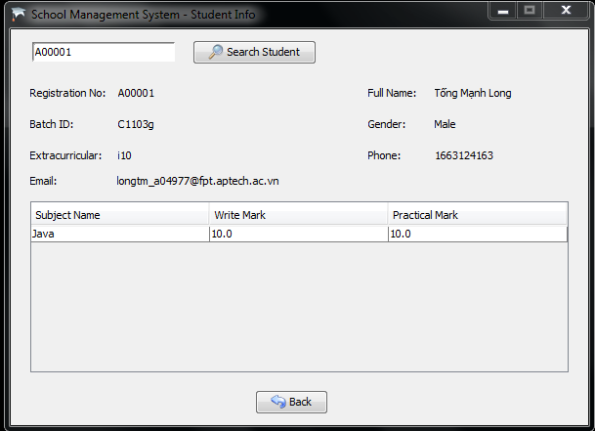

|  |  |  |  |  |  |
| --- | --- | --- | --- | --- | --- |
| No | Name | Type | Validation | Event | Description |
| 1 | registratonNo | TextField |  | No | Enter Reg No to search |
| 2 | btnSearch | Button |  | Yes | Search student by RegNo |
| 3 | btnBack | Button |  | Yes | Back to Welcome form |

1. Control Center
   1. Admin Control Center

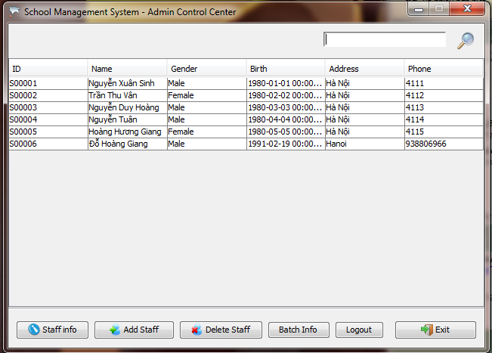

|  |  |  |  |  |  |
| --- | --- | --- | --- | --- | --- |
| No | Name | Type | Validation | Event | Description |
| 1 | staffData | Table |  |  | Display staff list |
| 2 | btnInfo | Button |  | Yes | Show staff info details |
| 3 | btnAdd | Button |  | Yes | Go to add staff form |
| 4 | btnDelete | Button |  | Yes | Delete a staff that be focus |
| 5 | btnSearch | Button |  | Yes | Search staff |
| 6 | btnExit | Button |  | Yes | Exit |
| 7 | staffID | TextField |  |  | enter staff ID to search |
| 8 | btnBatchInfo | TextField |  | Yes | Go to batch info form |
| 9 | btnLogout | Button |  | Yes | Logout application |

* + 1. Admin Control Center – Staff Info

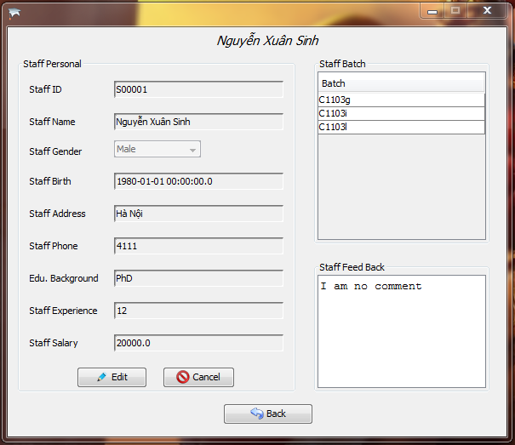

|  |  |  |  |  |  |
| --- | --- | --- | --- | --- | --- |
| No | Name | Type | Validation | Event | Description |
| 1 | staffEducationBackGround | TextField | Not blank | No | staff education background |
| 2 | staffPhone | TextField | Not blank | No | staff phone number |
| 3 | staffExperience | TextField | Not blank | No | staff experience |
| 4 | staffSalary | TextField | Not blank | No | staff salary |
| 5 | staffAddress | TextField | Not blank | No | staff address |
| 6 | staffBirth | TextField | Not blank | No | staff birthday |
| 7 | staffGender | ComboBox | Not blank | No | staff gender |
| 8 | staffname | TextField | Not blank | No | staff full name |
| 9 | staffID | TextField | Not blank | No | staff ID |
| 10 | btnEditStaffPersonal | Button |  | Yes | edit staff personal info |
| 11 | btnCancel | Button |  | Yes | Cancel edit staff info |
| 12 | staffBatch | Table |  |  | Display batch of staff |
| 13 | btnEditFB | Button |  | Yes | Edit the feedback |
| 14 | btnCancelFB | Button |  | Yes | Cancel feedback |
| 15 | btnBack | Button |  | Yes | Back to Admin Control… |

* + 1. Admin Control Center – Add staff

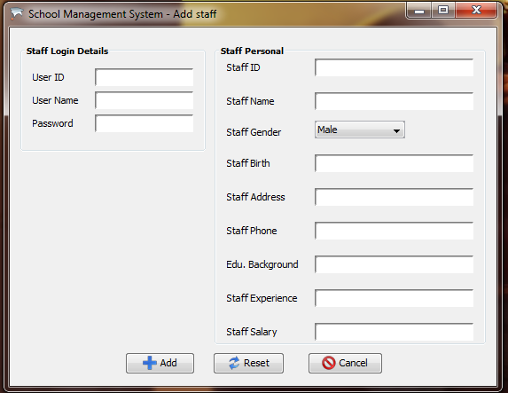

|  |  |  |  |  |  |
| --- | --- | --- | --- | --- | --- |
| No | Name | Type | Validation | Event | Description |
| 1 | staffEducationBackGround | TextField | Not blank | No | staff education background |
| 2 | staffPhone | TextField | Not blank | No | staff phone number |
| 3 | staffExperience | TextField | Not blank | No | staff experience |
| 4 | staffSalary | TextField | Not blank | No | staff salary |
| 5 | staffAddress | TextField | Not blank | No | staff address |
| 6 | staffBirth | TextField | Not blank | No | staff birthday |
| 7 | staffGender | ComboBox | Not blank | No | staff gender |
| 8 | staffname | TextField | Not blank | No | staff full name |
| 9 | staffID | TextField | Not blank | No | staff ID |
| 10 | userName | TextField | Not blank | No | Name to login |
| 11 | userID | TextField | Not blank | No | ID of user |
| 12 | password | password Field | Not blank | No | Password to login |
| 13 | btnReset | Button |  | Yes | Clear all textfield |
| 14 | btnCancelStaffPersonal | Button |  | Yes | Close this form |
| 15 | btnAddStaffPersonal | Button |  | Yes | Add staff and all information |

3.1.2 Admin Control Center – Batch Info

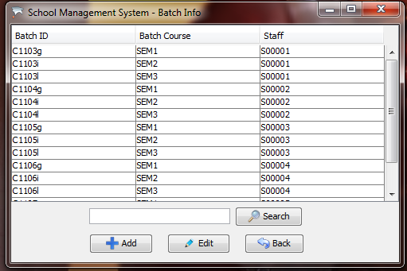

|  |  |  |  |  |  |
| --- | --- | --- | --- | --- | --- |
| No | Name | Type | Validation | Event | Description |
| 1 | tbData | Table |  | No | Display batch info |
| 2 | search | TextField |  | No | enter info to search |
| 3 | btnAddBatch | Button |  | Yes | Add a batch |
| 4 | btnEdit | Button |  | Yes | Edit a batch |
| 5 | btnBack | Button |  | Yes | Back to Admin Control |

* 1. Staff Control Center

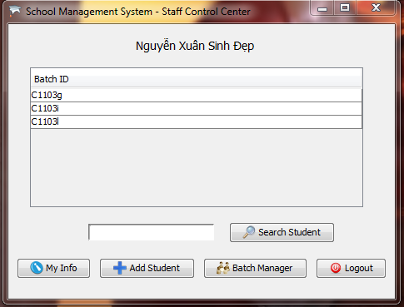

|  |  |  |  |  |  |
| --- | --- | --- | --- | --- | --- |
| No | Name | Type | Validation | Event | Description |
| 1 | batchData | Table |  | No | Display all batch of staff |
| 2 | btnBatchManager | Button |  | Yes | Go to Batch Manager |
| 3 | btnAdd | Button |  | Yes | Add new student |
| 4 | search | TextField |  | No | Enter RegNo to search |
| 5 | btnSearch | Button |  | Yes | Search student by RegNo |
| 6 | btnMyInfo | Button |  | Yes | Show staff personal info |
| 7 | btnLogout | Button |  | Yes | Logout staff account |

* + 1. Staff Control Center – My Info

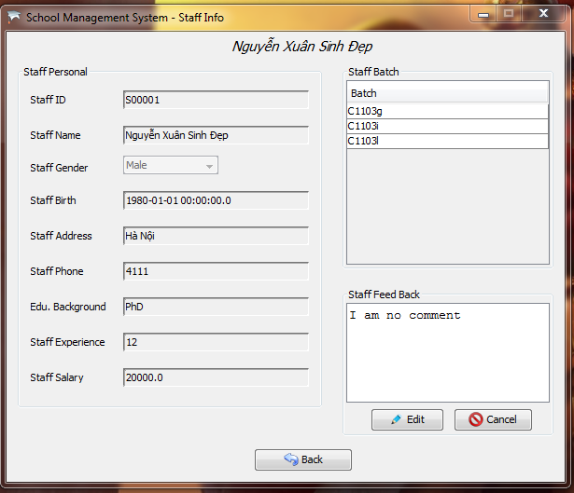

|  |  |  |  |  |  |
| --- | --- | --- | --- | --- | --- |
| No | Name | Type | Validation | Event | Description |
| 1 | staffEducationBackGround | TextField | Not blank | No | staff education background |
| 2 | staffPhone | TextField | Not blank | No | staff phone number |
| 3 | staffExperience | TextField | Not blank | No | staff experience |
| 4 | staffSalary | TextField | Not blank | No | staff salary |
| 5 | staffAddress | TextField | Not blank | No | staff address |
| 6 | staffBirth | TextField | Not blank | No | staff birthday |
| 7 | staffGender | ComboBox | Not blank | No | staff gender |
| 8 | staffname | TextField | Not blank | No | staff full name |
| 9 | staffID | TextField | Not blank | No | staff ID |
| 12 | staffBatch | Table |  |  | Display batch of staff |
| 13 | btnEditFB | Button |  | Yes | Edit the feedback |
| 14 | btnCancelFB | Button |  | Yes | Cancel feedback |
| 15 | btnBack | Button |  | Yes | Back to Admin Control… |

* + 1. Staff Control Center – Add Student

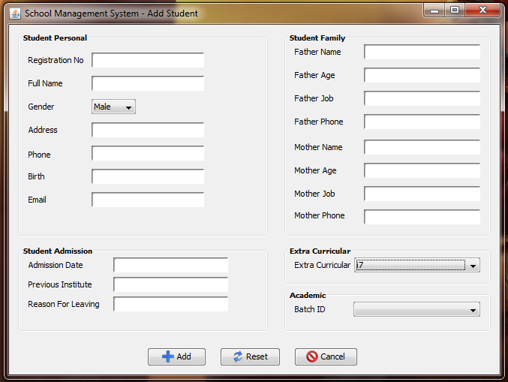

|  |  |  |  |  |  |
| --- | --- | --- | --- | --- | --- |
| No | Name | Type | Validation | Event | Description |
| 1 | regNo | TextField | Not blank | No | Student Registration No |
| 2 | fullName | TextField | Not blank | No | Student full name |
| 3 | address | TextField | Not blank | No | Student address |
| 4 | phone | TextField | Not blank | No | Student phone number |
| 5 | birthDate | TextField | Not blank | No | Student birthday |
| 6 | email | TextField | Not blank | No | Student email |
| 7 | gender | ComboBox | Not blank | No | Student gender |
| 8 | batchID | ComboBox | Not blank | No | Student Batch ID |
| 9 | exCur | ComboBox | Not blank | No | extra curricular |
| 10 | admDate | TextField | Not blank | No | Admission Date |
| 11 | preIns | TextField | Not blank | No | previous institute |
| 12 | rfl | TextField |  | No | Reason for leaving |
| 13 | faName | TextField |  | No | Father name |
| 14 | faAge | TextField |  | No | Father age |
| 15 | faJob | TextField |  | No | Father job |
| 16 | faPhone | TextField |  | No | Father phone |
| 17 | moName | TextField |  | No | Mother name |
| 18 | moAge | TextField |  | No | Mother age |
| 19 | moJob | TextField |  | No | Mother job |
| 20 | moPhone | TextField |  | No | Mother phone |
| 21 | reset | Button |  | Yes | Clear all textfield |
| 22 | addStudent | Button |  | Yes | Add a new student |
| 23 | cancel | Button |  | Yes | Exit Add student form |

* + 1. Staff Control Center – Batch manager

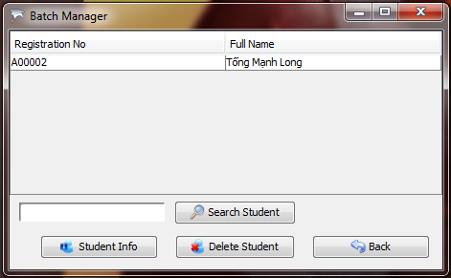

|  |  |  |  |  |  |
| --- | --- | --- | --- | --- | --- |
| No | Name | Type | Validation | Event | Description |
| 1 | tbData | Table |  | No | Display student in batch |
| 2 | btnStudentInfo | Button |  | Yes | Show student personal info |
| 3 | btnBack | Button |  | Yes | Back to Staff Control Center |
| 4 | btnDelete | Button |  | Yes | Delete a student |
| 5 | search | TextField |  | No | Enter Reg No |
| 6 | btnSearch | Button |  | Yes | Search student by RegNo |

* + - 1. Staff Control Center – Batch Manager – Student Info

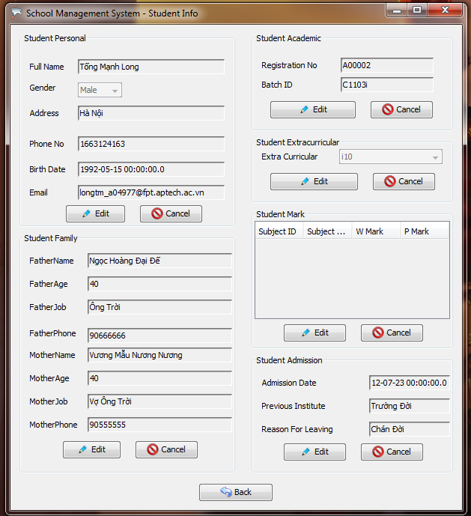

|  |  |  |  |  |  |
| --- | --- | --- | --- | --- | --- |
| No | Name | Type | Validation | Event | Description |
| 1 | btnBack | Button |  | Yes | Back to Batch manager |
| 2 | regNo | TextField | Not blank | No | Registraton number |
| 3 | batchID | TextField | Not blank | No | Batch ID |
| 4 | btnEditAcademic | Button |  | Yes | Edit Academic info |
| 5 | btnCancelAcademic | Button |  | Yes | Cancel edit academic info |
| 6 | fullName | TextField | Not blank | No | Student fullname |
| 7 | gender | ComboBox | Not blank | No | Student gender |
| 8 | address | ComboBox | Not blank | No | Student address |
| 9 | phoneNo | TextField |  | No | Student phone number |
| 10 | birthDate | TextField | Not blank | No | Student birthday |
| 11 | btnEditPersonal | Button |  | Yes | Edit student personal info |
| 12 | btnCancelPersonal | Button |  | Yes | Cancel edit student personal info |
| 13 | faName | TextField |  | No | Father name |
| 14 | faAge | TextField |  | No | Father age |
| 15 | faJob | TextField |  | No | Father job |
| 16 | faPhone | TextField |  | No | Father phone |
| 17 | moName | TextField |  | No | Mother name |
| 18 | moAge | TextField |  | No | Mother age |
| 19 | moJob | TextField |  | No | Mother job |
| 20 | moPhone | TextField |  | No | Mother phone |
| 21 | btnEditFamily | Button |  | Yes | Edit student family info |
| 22 | btnCancelFamily | Button |  | Yes | Cancel edit student family info |
| 23 | exCur | ComboBox | Not blank | No | extra curricular |
| 24 | admDate | TextField | Not blank | No | Admission Date |
| 25 | preIns | TextField | Not blank | No | previous institute |
| 26 | rfl | TextField |  | No | Reason for leaving |
| 27 | btnEditAdmission | Button |  | Yes | Edit student admission |
| 28 | btnCancelAdmisson | Button |  | Yes | Cancel edit student admission |
| 29 | exCur | ComboBox | Not blank | No | Extra Curricular |
| 30 | btnEditEx | Button |  | Yes | Edit extra curricular |
| 31 | btnCancelEx | Button |  | Yes | Cancel edit extra curricular |
| 32 | tbMark | Table |  | No | Display mark |
| 33 | btnEditMark | Button |  | Yes | Edit mark |
| 34 | btnCancelMark | Button |  | Yes | Cancel edit mark |

Staff Control Center – Student Info – Add Mark

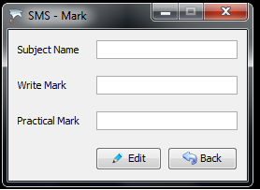

|  |  |  |  |  |  |
| --- | --- | --- | --- | --- | --- |
| No | Name | Type | Validation | Event | Description |
| 1 | pMark | TextField | Not blank |  | Practice mark |
| 2 | wMark | TextField | Not blank |  | Write mark |
| 3 | subjectName | TextField | Not blank |  | Name of subject |
| 4 | btnEdit | Button |  | Yes | Edit mark of subject |
| 5 | btnBack | Button |  | Yes | Back to Staff Control |